**Course: Advance Bio Informatics**

**Module Title: Pharmacogenetics Applications**

**Module No:116**

**Pharmacogenetics**

It is the branch of pharmacology concerned with the effect of genetic factors on reactions to drugs.

It tries to answer the following question; how people respond to medicines? It tries to correlate heritable genetic variation to drug response

Pharmacogenetics is the study of inherited genetic differences in drug metabolic pathways which can affect individual responses to drugs, both in terms of therapeutic effect as well as adverse effects. The term pharmacogenetics is often used interchangeably with the term pharmacogenomics which also investigates the role of acquired and inherited genetic differences in relation to drug response and drug behavior through a systematic examination of genes, gene products, and inter- and intra-individual variation in gene expression and function.

In oncology, pharmacogenetics historically is the study of germline mutations (e.g., single-nucleotide polymorphisms affecting genes coding for liver enzymes responsible for drug deposition and pharmacokinetics), whereas pharmacogenomics refers to somatic mutations in tumoral DNA leading to alteration in drug response (e.g., KRAS mutations in patients treated with anti-Her1 biologics)

**Definition:** Biotechnological science combines techniques of

(i) Medicine

(ii) Pharmacology

(iii) Genomics

For developing drug therapies to compensate for genetic differences in patients which cause varied responses to a single therapeutic regimen.

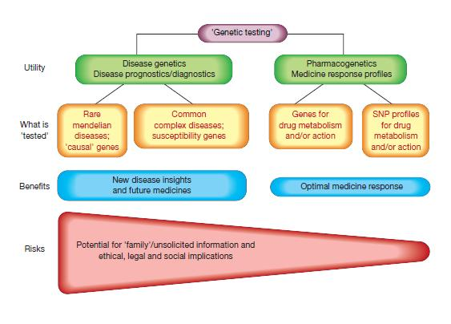

**Pharmacogenetics Applications:**

* Detection of genetic variability of drug effects on the genome level
* Agent selection
* Analysis of drug reactions and drug toxicity on gene expression
* Development of new indications for already approved drugs
* Discovery of new drug targets
* Identification of (non) responders in clinical trials of phase I-IV
* Identification of genotype dependent adverse drug reactions
* Identification of individuals at risk for severe adverse drug effects